Nama : Sevia Ayu Wandinda

NPM : G1F021005

Matkul : Algoritma & Struktur Data

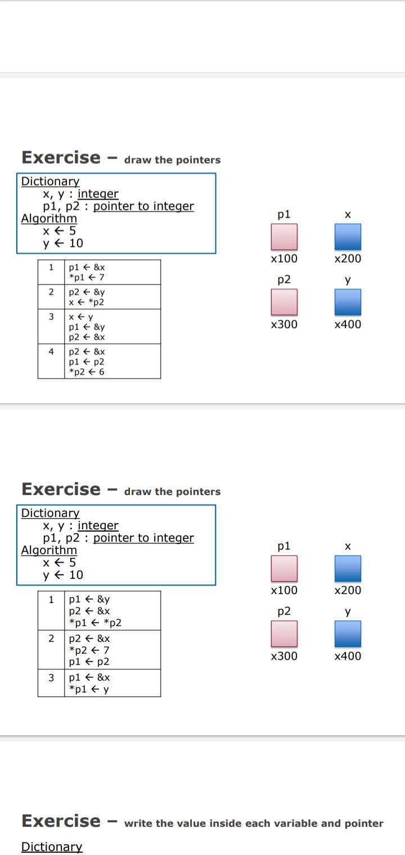

1. P1 &X

*P1 7

P1 X



7

X200 X200

P2 Y



10

X300 X400

1. P2 &Y

X  *P2

P1 X



10

X200 X200

P2 Y



10

X400 X400

1. X Y

P1 &Y

P2 &X

P1 X



10

X400 X200

P2 Y



10

X400 X400

1. P2 &X

P1  P2

*P2 6

P1 X

6

 X200

X200

P2 Y

10

 X400

X200



1. P1 &Y

P2 &X

*P1*P2

P1 X



5

X400 X200

P2 Y



5

X200 X400

1. P2 &X

*P2 7

P1  P2

P1 X



7

X200 X200

P2 Y



5

X200 X400

1. P1 &X

*P1 Y

P1 X

5



X200 X200

P2 Y



5

X200 X400

Dictionary

a, b, c : integer

p1,p2,p3 : pointer to integer

Algorithm

A <- 10

B <- 15

p1 <- &b

p2 <- p1

c <- 27

p1 <- &c

a <- *p1

p3 <- &b

*p2 <- 8.

Wht is the Output?

|  |  |  |  |  |  |
| --- | --- | --- | --- | --- | --- |
| a | b | c | P1 | P2 | P3 |
| 10 | 15 | 27 | 15 | 15 | 15 |
| 27 |  |  | 27 | 8 |  |
|  |  |  |  |  |  |
|  |  |  |  |  |  |
|  |  |  |  |  |  |
|  |  |  |  |  |  |
|  |  |  |  |  |  |
|  |  |  |  |  |  |
|  |  |  |  |  |  |

Dictionary

a, b, c : integer

p1,p2,p3 : pointer to integer

Algorithm

A <- 10

B <- 15

c <- 27

p1 <- &a

p2 <- &b

*p1 <- c

a <- *p2

b <- 6

p3 <- &b

p3 <- &c

*p1 <- *p3

|  |  |  |  |  |  |
| --- | --- | --- | --- | --- | --- |
| a | b | c | P1 | P2 | P3 |
| 10 | 15 | 27 | 10 | 15 | 6 |
| 15 | 6 |  | 27 |  | 27 |
|  |  |  | 27 |  |  |
|  |  |  |  |  |  |
|  |  |  |  |  |  |
|  |  |  |  |  |  |
|  |  |  |  |  |  |
|  |  |  |  |  |  |
|  |  |  |  |  |  |